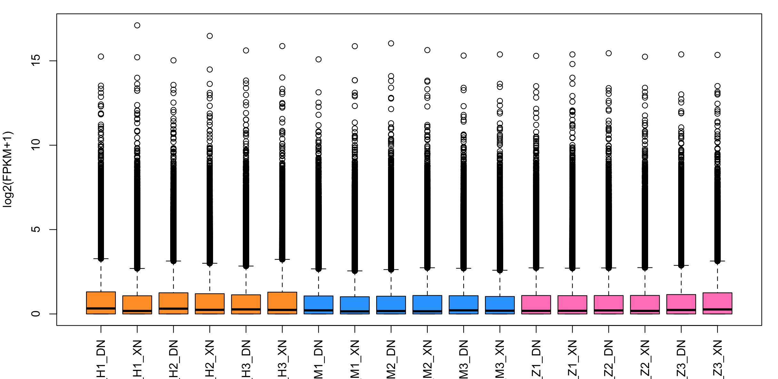
Figure S1. Total transcript expression level of each sample. Different group were marked by different color.

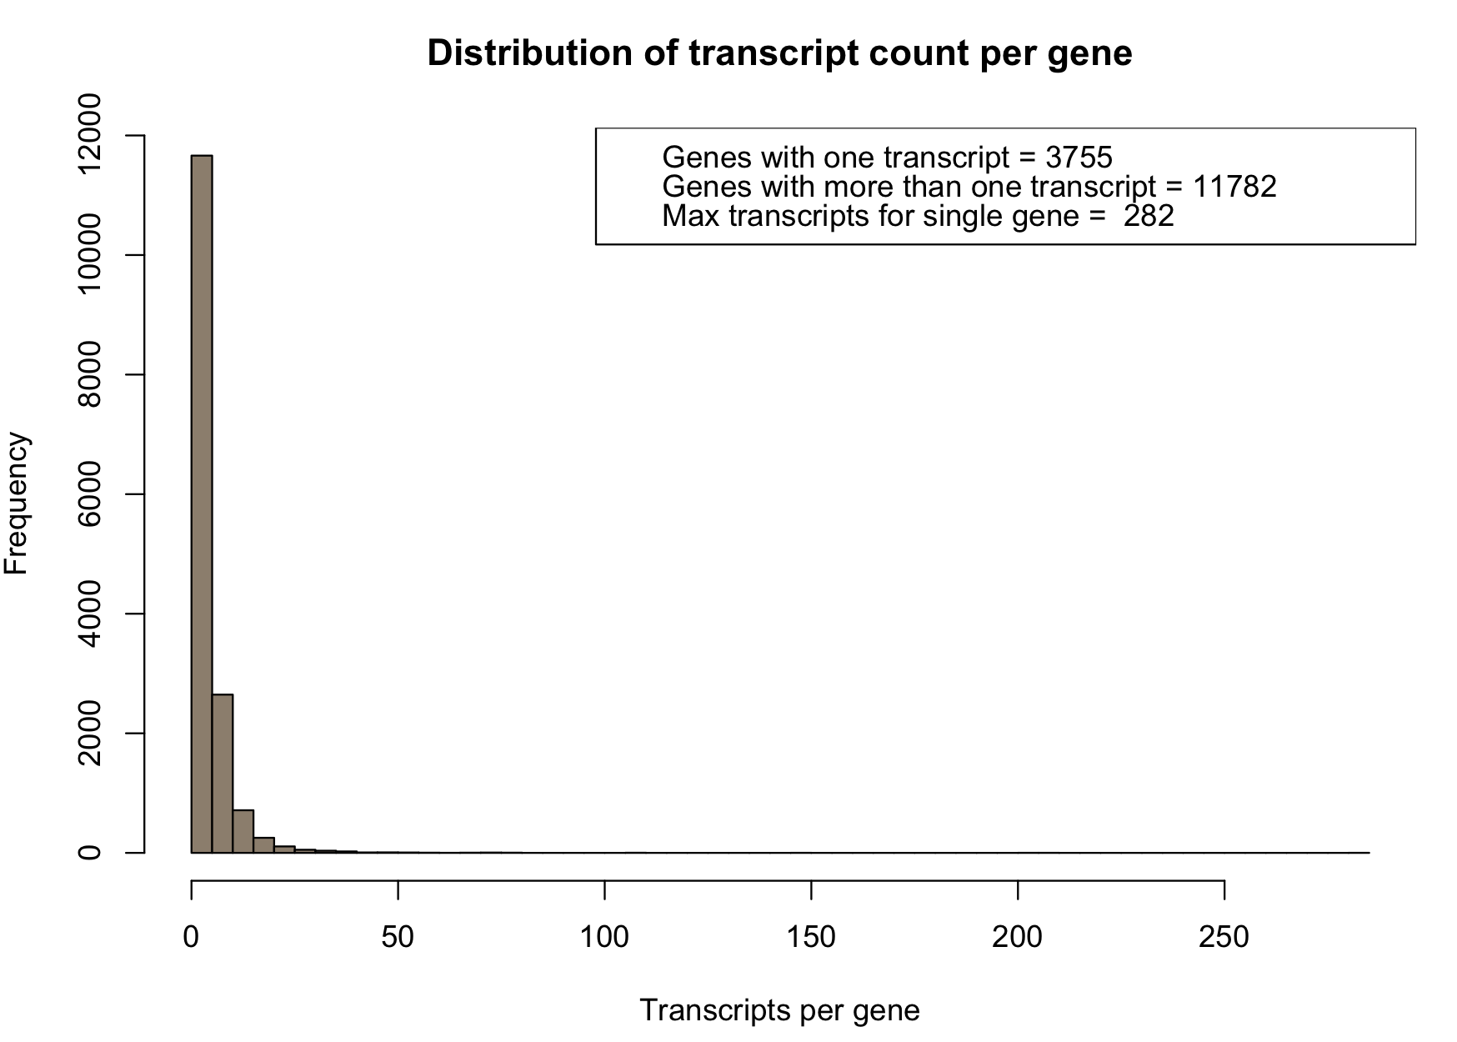
Figure S2. Distribution of total transcript count per gene. The gene is referred by BosGru_v2.0 annotation file. The ratio of genes with only one transcript is 24.16%.

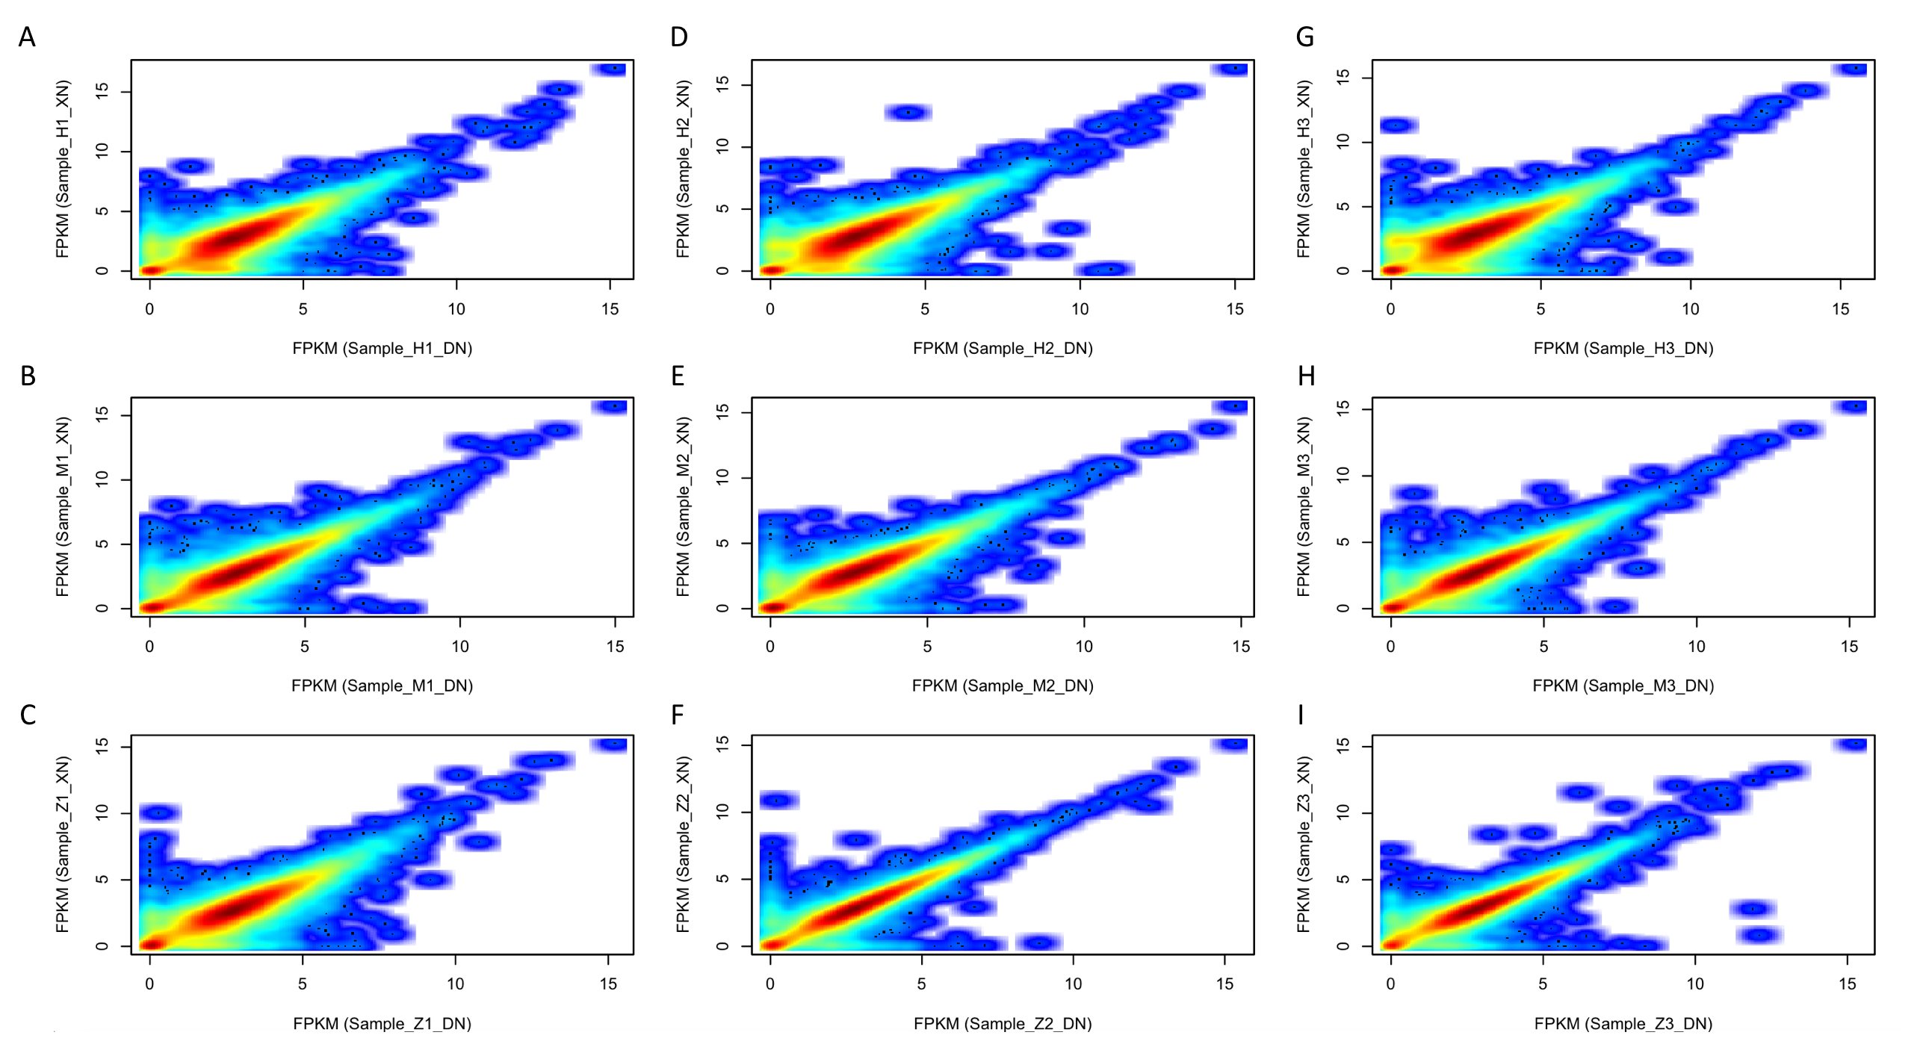
Figure S3. The repeatability validated heatmap between DN and XN in each sample. Comparing expression level of different tissue in same sample, we used heatmap of log2(FPKM) between two tissue to represent the relationship. The correlated level ( from weak to strong) was indicated by white, blue, cyan, yellow and red.

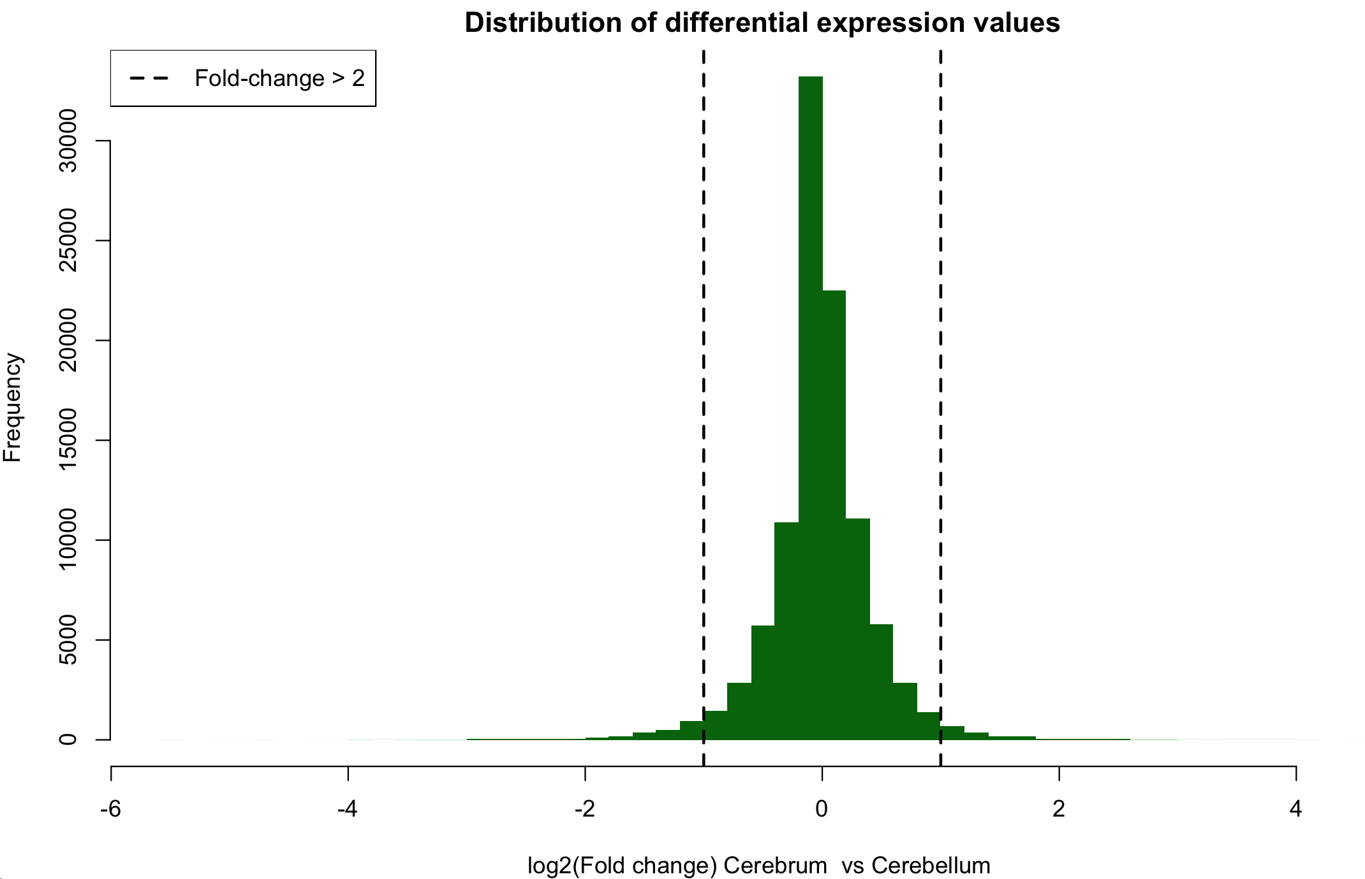
Figure S4. The screening Different Expression gene between Cerebrum and Cerebellum in all groups.

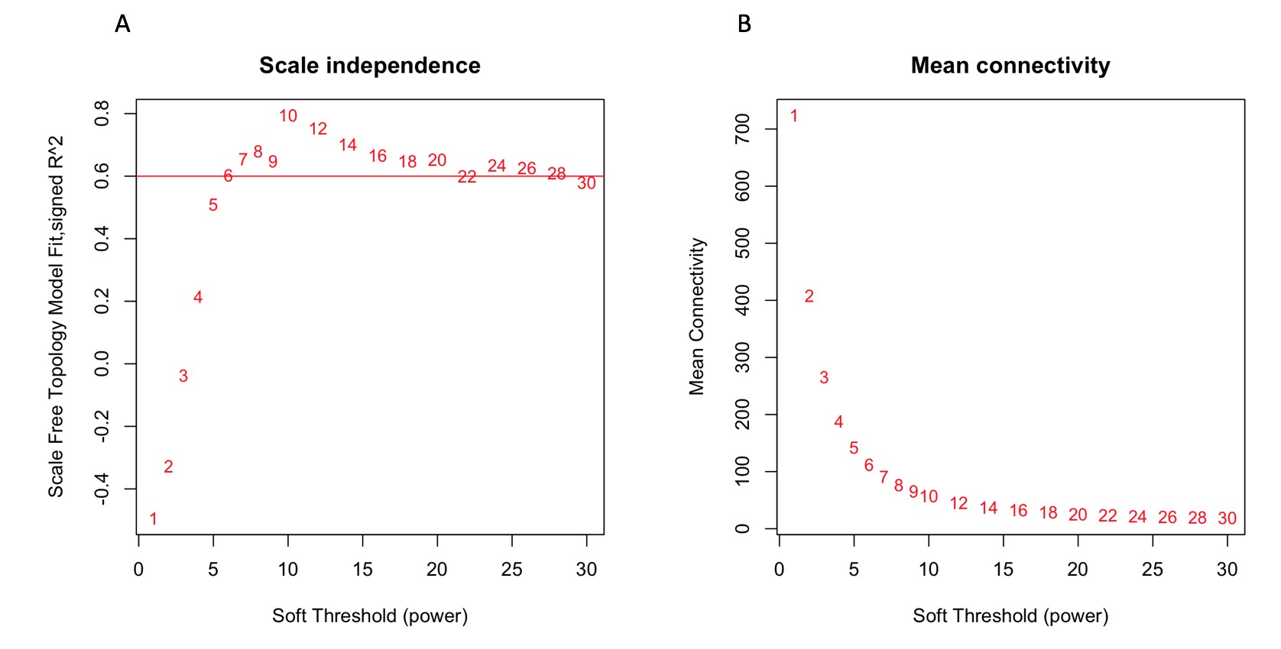 Figure S5. Optimized and selected soft threshold (power) for creating modules networks. To make modules networks according with estimated character of no-scale network, we used pickSoftThreshold function of GWCNA to optimize and select soft threshold. A scale independence was estimated by each lop. The R square of filter criteria was set 0.6. B mean connectivity of each lop was compared with soft threshold. The more smooth and steady of mean connectivity, the estimated model will be better.

Samples | Number of reads | Total mapping ratio | Unique mapping
H1_DN | 54585463 | 84.56% | 76.49%
H1_XN | 49443112 | 88.64% | 79.91%
H2_DN | 49211828 | 88.36% | 80.66%
H2_XN | 55739895 | 90.22% | 82.36%
H3_DN | 48586705 | 89.42% | 81.60%
H3_XN | 52066284 | 89.81% | 82.29%
M1_DN | 50444283 | 95.35% | 89.15%
M1_XN | 54075865 | 94.16% | 87.23%
M2_DN | 49933848 | 94.56% | 88.02%
M2_XN | 52388182 | 94.83% | 88.11%
M3_DN | 52423296 | 95.10% | 88.83%
M3_XN | 49659936 | 94.80% | 88.50%
Z1_DN | 40500355 | 92.93% | 85.60%
Z1_XN | 47059574 | 92.47% | 84.71%
Z2_DN | 47797658 | 90.01% | 82.15%
Z2_XN | 51386058 | 91.00% | 83.33%
Z3_DN | 51061243 | 91.32% | 83.64%
Z3_XN | 46301923 | 90.79% | 83.35%
Table S1. Mapping result with refer genome in each sample.

